**Prerequisites Software:**

1. Eclipse or intellij editor

2. Java

3. Maven install and setup

4. TestNG install and setup in eclipse

**Extract the Downloaded or Cloned Project**

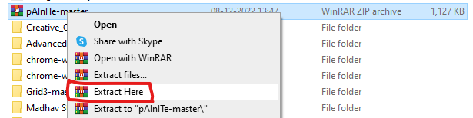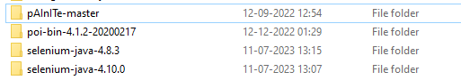

Launch Eclipse and go to File-> Import

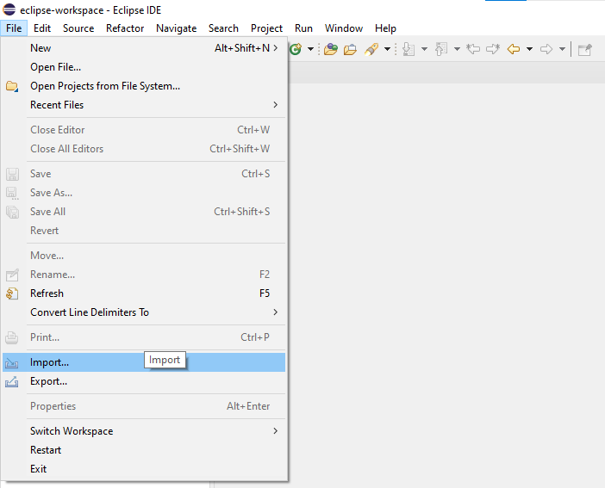

**Select Existing Maven Project**

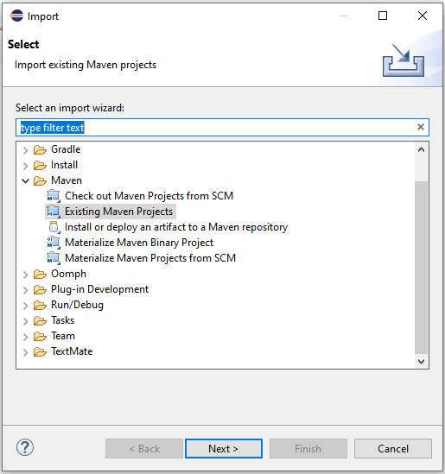

**Browse to select the project**

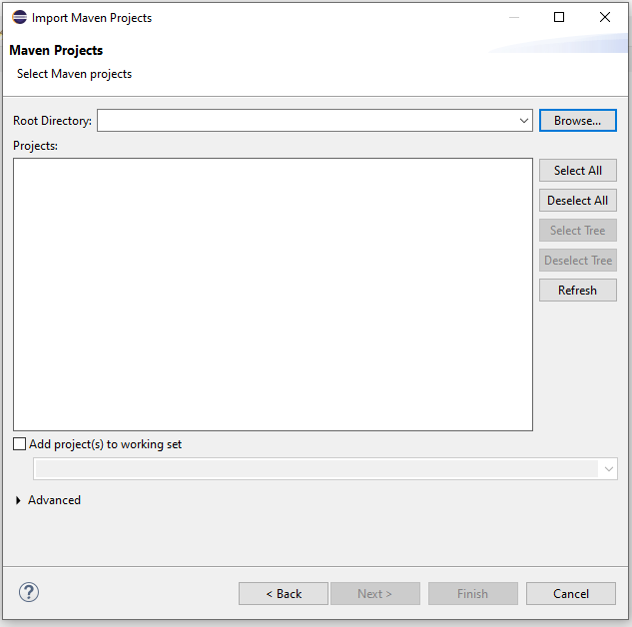

**Select the project**

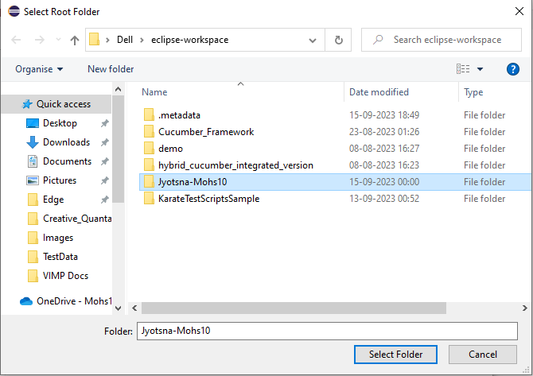

**Check the pom.xml path checkbox**

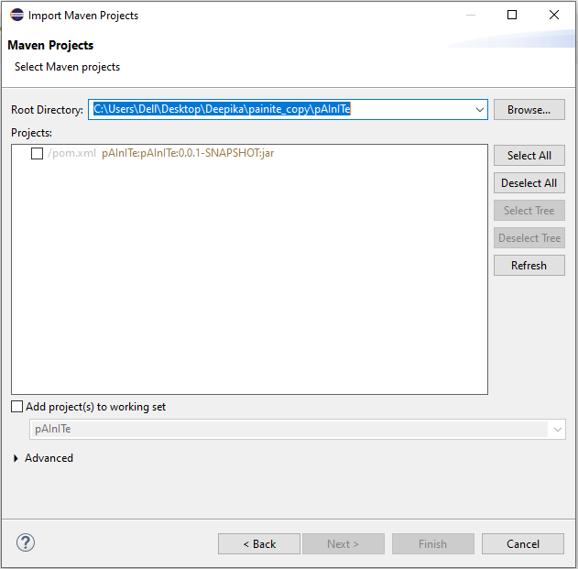

**Project is ready in Eclipse - just update the project and pom.xml**

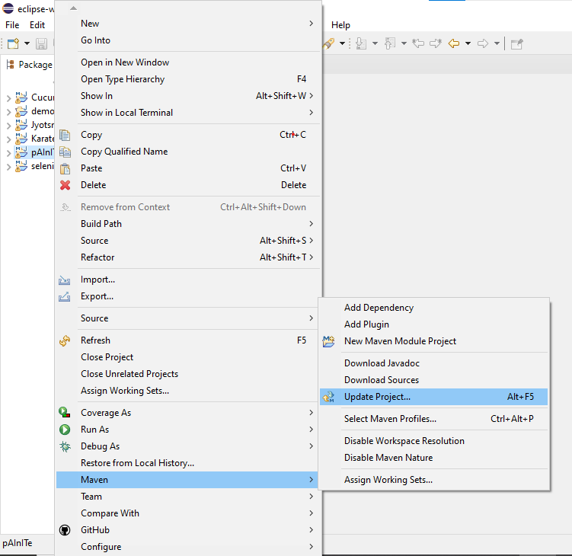

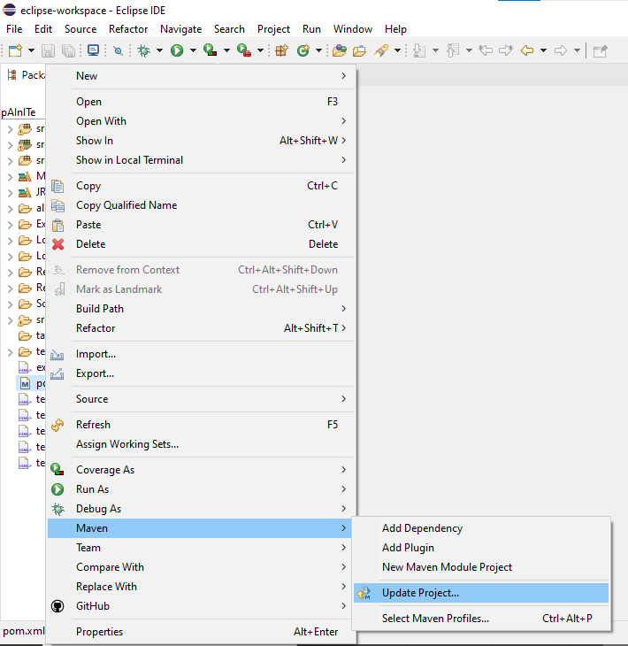

**Open the pom.xml and make some changes to run the project in eclipse**

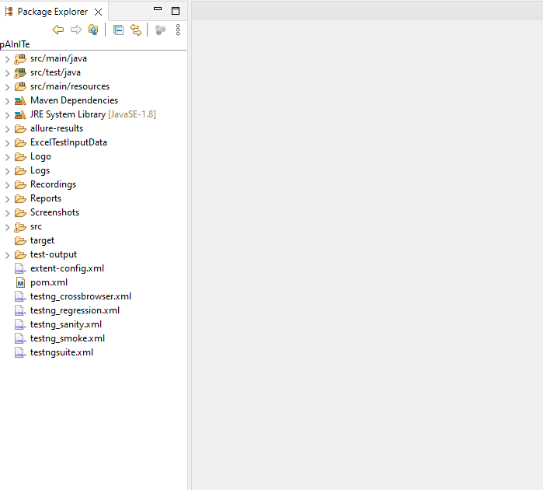

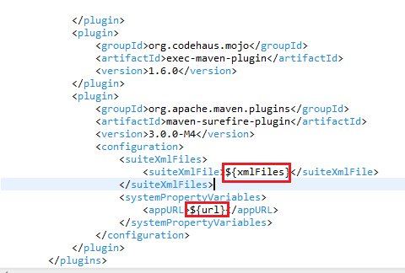

Update ${xmlFiles} to below like **testngsuite.xml or any other suites from below**

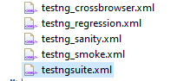

Update ${url} to below URL

App url: <http://jyotsnaprod.ap-south-1.elasticbeanstalk.com/login>

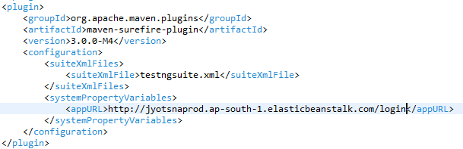

**Now run the Project:**

